Emi Husband
emi.husband@northumbria.ac.uk

Bio
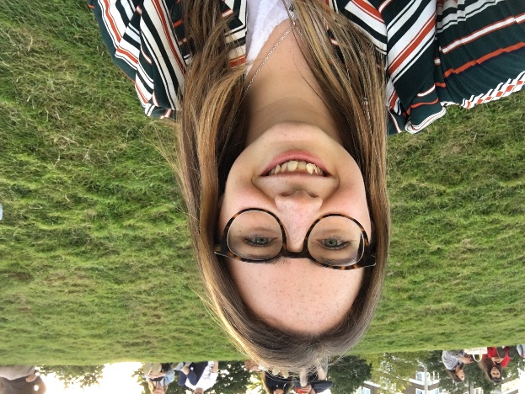
My fascination for the oceans, coral reefs and palaeo-environments developed during my undergraduate geography degree, and thereafter during my masters where I first visited a coral reef and dived – quite literally – into coral reef science. My MSc research focussed on coral reef structural complexity, particularly at the colony level, and led me to develop the Coral Colony Rugosity Index – a new approach that enables 3D coral colony rugosity data to be extracted from underwater and drone imagery, and used in reef carbonate budget work. This project increased my awe for coral reefs, not only as unique and colourful environments swarming with life under the sea, but also as fundamental ecosystems for the health of the ocean and planet, coastal communities, and the existence of coral reef islands of which so much remains unknown!
My PhD now enables me to bring together my geographical knowledge of coasts and palaeo-environments, and reef ecology experience in an exciting project which will be the first, globally to investigate the formation and evolution of Caribbean reef islands.
Research Questions
My PhD lies at the intersection between palaeo-environmental science, contemporary reef ecology, and coastal processes. It aims to reconstruct the development of, and identify the key controls on the formation and evolution of Caribbean coral reef islands over both contemporary and millennial timescales.
- When did reef island initiation occur, and what was the rate and mode of island formation?
- What were the key environmental and ecological controls on Caribbean reef island development during the Holocene?
- Which reef organisms were/are most significant for island formation and what is the present degree of reef-to-island connectivity
- What are the key 3D morphological characteristics of reef islands and how does reef island morphology change over a monthly and annual timescales
Techniques
I am employing various palaeo- and contemporary methods, including: sediment coring and chrono- and bio-stratigraphic analysis to reconstruct reef island accretionary histories; reef ecological surveys and sediment budgets to assess the key contemporary sediment producers on coral reefs and the degree of reef-to-island connectivity; GIS techniques to analyse reef island 2D shoreline change; and, 3D modelling using drone imagery to examine reef island morphology and evolution in 3D.
Supervisors
- Holly East, Northumbria University
- James Guest, CORALASSIST, Newcastle University
- Emma Hocking, Northumbria University
- Pauline Gulliver, SUERC, University of Glasgow
- Dan Exton, Operation Wallacea

